Marketing Guide

## Background:

* **Background**: The professional networking platform Linkedin provides a well suited plethora of opportunities to experienced professionals but has a set back for recent college graduates. We are willing to expand our job search market for recent graduates by recommending them best suited jobs based on their skills and preferences and prepare them to face the rigorous interview process of various companies.
* **Problem Statement**: How can LinkedIn make the platform more desirable for new graduates and groom them to land in their dream job ?
* **Product Goals**: LinkedIn will be launching an interview preparation module and mentorship program so that new graduates with almost no interviewing experience can prepare for landing a job. These new modules will be solving major problems by:
  + Upskilling the users with recommended courses based on their aspirations and goals.
  + Providing training for improving interviewing skills using and understanding of users’ strengths and weaknesses from his LinkedIn Profile and previous feedback from mock interview service.
  + Provide expert mentorship guidance to work upon their weak points.

## Market background:

* **Target Audience**: The target population are new graduates and to-be graduates between the age of 18-29 who are about to complete their graduation and enter the job market.
* **Target Market:** We will target the Indian market for now since-
  + Second largest market with 66M users.
  + Highest graduate growth rate.
  + Highest Youth population in the world.
* **Competitors**: LinkedIn’s major competitors are Naukri, Indeed, Shine, MonsterIndia and a bunch of startups like Amcat, elitmus, cocubes, TopHire etc.
  + Analysis of Top competitors to find the user base, revenue and market share captured is as follows:
    - Naukri :
      * #Users: 50M
      * Online Traffic: 18M
      * Revenue: $65M
      * Market Share: 55%

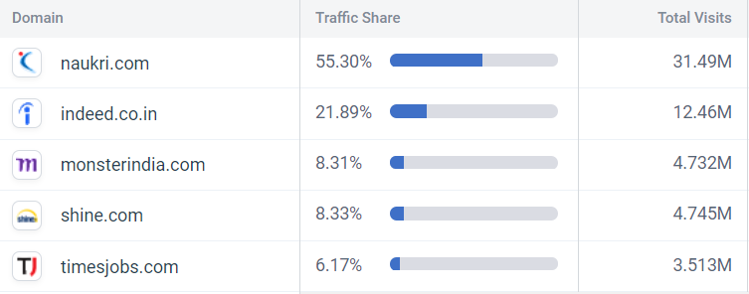

* + - Indeed :
      * #Users: 20M
      * Online Traffic: 12M
      * Revenue: <$30M
      * Market Share: 21.89%

## Product Background and Positioning: LinkedIn freshers will provide a wide range of features that will foster skills, learnings, confidence in new candidates and help them land in their dream job and boost their career.

* Value proposition for LinkedIn: New Grads:
  + **Target Users:** New graduates and to-be graduates between the age 18-29 looking for a new job
  + **Value Proposition:** The new feature provides an end-to-end solution for studying, practicing and securing expert advice for improving interviewing skills to the new graduates and students.
  + **Benefits**:
    - A personalized experience to the new graduates to find study materials related to his skills, interests and goals
    - Provide comprehensive feedback and curated recommendations to work upon weaknesses
    - Find the best mentors in industry and academia to guide new graduates and improve their skills while providing good networking
    - Provides job recommendations based on profile, goals and aspirations.
  + **Marketing Message:** “***Opportunities today for the leaders of tomorrow***”
* The three major features are:
  + **Profile based Job Recommendation** : Users will get various job / internships recommended to them based on their profile, dream, aspirations and career goals.
  + 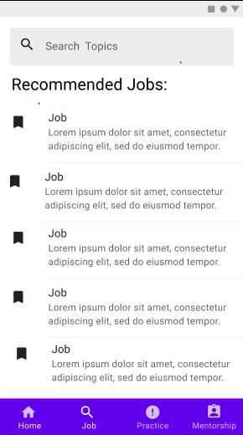

*Profile based job recommendations*

* + **AI based mock interview service**: Users can practice mock interviews with the AI service which records the sessions, evaluates user response and body language and outputs feedback with strengths and weaknesses .

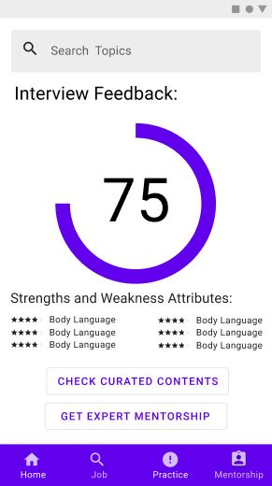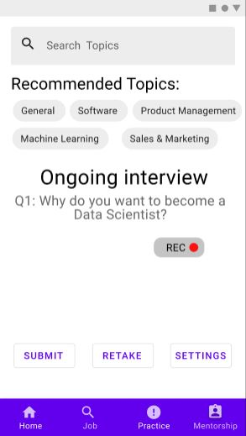

*Interview service and feedback for users*

* + **Expert mentors from academia and industry**: Users can find suggested experts in their areas of interests and request help from mentors, with whom they can converse and hold a session via LinkedIn app itself to receive advice and areas of improvement. Further they can rate the service and provide feedback to get better curation and recommendations later.

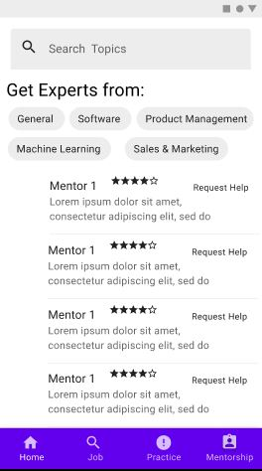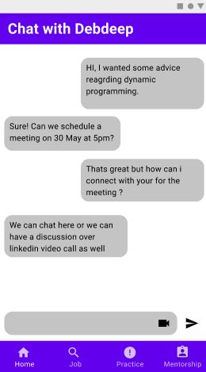

*Mentorship service and interaction platform*

* Users can find the new service “LinkedIn Freshers “ in the drop down options from the top corner left in the linkedin app from where they will be redirected to the new app or can directly log in to the new app from the play store.
* **Training guide**: <https://docs.google.com/document/d/1xFZCxH47TvdNWHqq9eTXceHaX6bNW1gQmC1wZEJImBo/edit?usp=sharing>